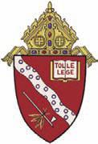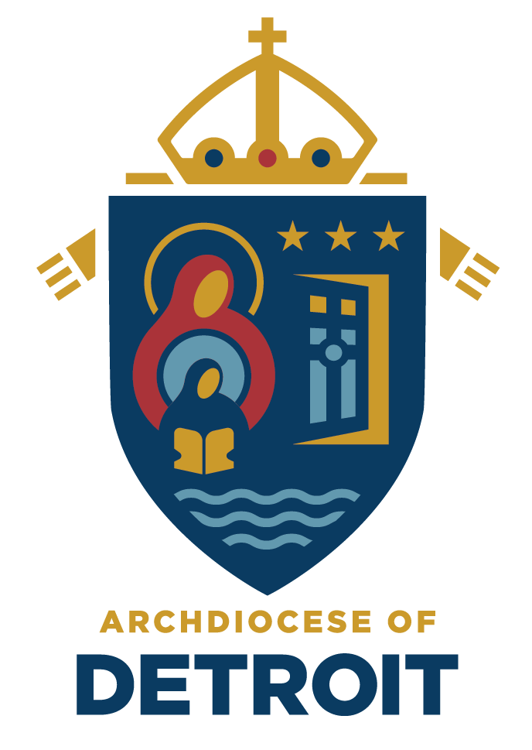

Catholic Diocese of Kalamazoo and Catholic Archdiocese of Detroit
Implementation Plan for Student Spaceflight Experiments Program (SSEP)
Mission 12 to the International Space Station

Community:
St. Fabian Catholic School; Farmington Hills, Archdiocese of Detroit
St. Monica Catholic School; Catholic Diocese of Kalamazoo

Proposed SSEP Community Program Directors:
Mrs. Becky Reits, Principal, St. Monica Catholic School, (269) 345-2444, breits@stmonicakzoo.org
Ms. Christina Sobolak, Middle School Science Teacher, St. Fabian Catholic School, (248) 553-2750, csobolak@stfabian.org
Miss Kate Willard, Advancement Director, Catholic Schools of Greater Kalamazoo, (269) 381-2646, kwillard@csgk.org

Proposed SSEP Leadership Team:
Mrs. Sharon Szuba, Principal, St. Fabian Catholic School
Mrs. Kathy Doud, Marketing Coordinator, St. Monica Catholic School

Proposed SSEP Community Program Team:
Mr. Zach Wilson, 4th Grade Teacher, All Subjects, St. Monica Catholic School
Mr. Bob Plotz, 5th Grade Teacher, All Subjects, St. Monica Catholic School
Mrs. Jennifer Crawford, 5th Grade Teacher, All Subjects, St. Monica Catholic School
Mrs. Katherine Hammer, 6th Grade Teacher, All Subjects, St. Monica Catholic School
Mrs. Diane Page, 7th & 8th Grade Science Teacher, St. Monica Catholic School
Mrs. Meagan McAfee, 7th & 8th Grade ELA Teacher, St. Monica Catholic School
Ms. Diane Matyas, 7th & 8th Grade Social Studies Teacher, St. Monica Catholic School
Mrs. Susie VanderBeek, 7th & 8th Hands-On Science Teacher, St. Monica Catholic School
Deacon Lucas, 7th & 8th Theology Teacher, St. Monica Catholic School
TBD, 7th & 8th Grade Math Teacher, St. Monica Catholic School
Mrs. Kim Lamp, K-8 Technology Teacher, St. Monica Catholic School
Ms. Sarah Polnasek, 4th & 5th Grade Science Teacher, St. Fabian Catholic School
Ms. Christina Sobolak, 6th-8th Grade Science Teacher, St. Fabian Catholic School
Mrs. Lindsey Sokana, 6th-8th Grade Technology Teacher, St. Fabian Catholic School
Ms. Courtney Nixon, 6th-8th Grade Literature Teacher, St. Fabian Catholic School
Mrs. Kimberly Kerwin, 6th-8th Grade Theology Teacher, St. Fabian Catholic School
Mr. Bruce Watkins, 6th-8th Grade English Teacher, St. Fabian Catholic School
Mrs. Jacqueline Barlow, 6th-8th Grade Math Teacher, St. Fabian Catholic School
Mr. Colin Sharp, 6th-8th Grade Social Studies Teacher, St. Fabian Catholic School

Summary of Proposed Program:
One elementary school in the Catholic Diocese of Kalamazoo and one middle school in the Archdiocese of Detroit propose to participate in the Student Spaceflight Experiments Program (SSEP) Mission 12 to the International Space Station (ISS). We intend to fully immerse close to 300 fourth, fifth, sixth, seventh, and eighth grade students across these dioceses in real-life scientific and engineering experiences through microgravity experiment design and research proposals. We will produce 50-55 flight experiment proposals at the conclusion of the nine-week project with the goal to have one group proposal from each school represented in Mission 12 to the ISS in spring 2018.

- Overview of our Community:
The Catholic Diocese of Kalamazoo is the territory of Catholic churches and community led by Bishop Paul J. Bradley. The diocese was founded in 1971 when the Second Vatican Council called for the creation of smaller dioceses so that bishops could be more available to the people they serve. Today the diocese encompasses 5,337 square miles of nine counties in southwest Michigan: Allegan, Barry, Van Buren, Kalamazoo, Calhoun, Berrien, Cass, St. Joseph and Branch and has grown to include 59 parishes as well as 22 Catholic schools and two stand-alone parish- based Catholic preschools.

St. Monica Catholic School
St. Monica Catholic School was built in 1958 and currently has a student body of 280 children in preschool through eighth grade. St. Monica Catholic School is accredited by the Michigan Non-public Schools Accrediting Association and is a member of the National Catholic Education Association. St. Monica Catholic Preschool is fully licensed through the State of Michigan. The ethnic makeup of the student body consists of .8% African American; 5.4% Asian; 87% Caucasian; 6.8% Multi-Racial. 10.6% of the student population receives free or reduced lunches.

Diocese of Kalamazoo Mission Statement

“In the spirit of Blessed John Paul II’s call for a New Evangelization, Catholic Schools of the Kalamazoo Diocese desire to respond to this transformative invitation to holiness with a firm and renewed zeal. As a multi-culturally diverse institution, we joyfully embrace the universal vocation to holiness.

We are a community centered in the Eucharistic Christ and an educational system of the highest standards, rooted in our Catholic faith. Our goal is to equip students with an excellent education and a solid faith formation so each student may know the faith confidently, live the faith in a community where families and teachers work together to advocate for each other’s salvation and Sainthood, and share the faith with relevance and loving courage throughout their lives.”

Formed by faith, we are a community of believers who strive to offer real-life educational opportunities that promote thinking, reasoning, exploring, and questioning from our students. We want to offer our students the opportunities to nurture and naturally embrace these 21st century skills that will enable them to sustain and transform our world now and for future generations.

The Archdiocese of Detroit dates back to 1701 and consists of 265 Roman Catholic parishes and 96 schools in southeast Michigan. It covers Lapeer, Oakland, Wayne, Macomb, St. Clair, and Monroe counties. Most Reverend Allen Vigneron is the Archbishop of the Archdiocese of Detroit.

St. Fabian Catholic School

St. Fabian Catholic School officially opened on September 8, 1965 and currently has 265 students in preschool through eighth grade. The school is accredited by the Michigan Non-Public Accrediting Association and is a member of the National Catholic Education Association. The preschool and Kids Club programs are licensed by the State of Michigan. Approximately 2% of the student population qualifies for free or reduced lunch. The ethnic makeup of the school is 3.8% Asian, 8.7% African American, 46.8% Chaldean, 2.3% Hispanic, 1.1% Middle Eastern, 0.38% Native Hawaiian or Other Pacific Islander, 35.5% Caucasian, and 6.0% Multi-Racial.

Archdiocese of Detroit Mission Statement
“Vision: To understand the essential role of Catholic schools in the mission of the Church, promote the evangelical mission of schools, centered on Christ, while enhancing their academic excellence & providing equal access through shared resources.
Goals:
- Catholic schools will have a strong Catholic culture in order to effectively maintain the mission for which Catholic schools were established.
- Catholic schools will be strong academically.
- A financial model will be developed to make Catholic schools accessible for every Catholic child in the AOD who wants to attend.
- Effective governance models will be developed for Catholic schools based on a Regional model.”

The Archdiocese of Detroit works to educate students to become innovative thinkers who think critically about the world around them, while strengthening their relationship with God. Providing opportunities for students to develop necessary skills for their futures is of great importance. The Archdiocese believes that fostering curiosity, creativity, and problem solving will ensure a successful future for the Detroit community and the rest of the world.

- Strategic Need in STEM Education and How SSEP Can Help Address These Needs

While our Catholic schools continue to work toward full implementation of the Next Generation Science Standards, our schools have consistently worked for the past four years, to implement the ‘Common Core Mathematical Practices’ that require students to 1. Make sense of problems and persevere in solving them; 2. Reason abstractly and quantitatively; 3. Construct viable arguments and critique the reasoning of others; 4. Model with mathematics; 5. Use appropriate tools strategically; 6. Attend to precision; 7. Look for and make use of structure; and 8. Look for and express regularity in repeated reasoning. These practices are nicely aligned with the ‘Practices for the K-12 Science Curriculum’ embedded in the Next Generation Science Standards: 1. Asking questions and defining problems; 2. Developing and using models; 3. Planning and carrying out investigations; 4. Analyzing and interpreting data; 5. Using mathematics and computational thinking; 6. Constructing explanations and designing solutions; 7. Engaging in argument from evidence; and 8. Obtaining, evaluating, and communicating information.

Through the nature of past SSEP Mission designs, our students will actively and regularly engage in the established best practices for math and science by competing among peer teams to “fly an experiment in low Earth orbit”. Our teams will design experiments on microgravity. All will be required to write research proposals and experience a formal proposal review and selection process. Teams will act as real researchers as they work to submit research proposals covering many diverse fields. Students will utilize their knowledge of the scientific method to design experiments that will sustain the environmental requirements for spaceflight. Students will learn the importance of collaboration as they work among their peers. Students will realize their connections with and between community members and will begin to understand the resources within our community and the vast contributions each one makes.

Within the scope of the scientific practices, this STEM program will encourage our students to become more aware of the world around them through discovery, inquiry, exploration, problem-solving, and communication, in collaboration with their peers. Through this program, we intend to reach and engage all levels of learners through the various modalities and to expose students to many unique career opportunities not otherwise known or understood within the confines of a traditional classroom.

A long range intended outcome is that education within our classrooms will illustrate greater emphases on student-centered instruction and collaboration that will be guided by teachers who facilitate the learning process. Ultimately, we believe that SSEP will help students to own and advocate for their education and will develop into more confident and capable learners.

- Proposed Program Scope

One school within the Catholic Diocese of Kalamazoo and one school within the Archdiocese of Detroit, comprised of nearly 300 fourth through eighth grade students, propose to form 50-55 grade-level student groups whose designated teachers will facilitate learning across all content areas at a minimum of 5 hours per week. Student groups will perform experiment design and research during the nine-week program, which will culminate in 50-55 total experiments and research proposals.

Nineteen teachers are committed to engaging our students in cross-curricular learning that will be centered on experiments and research conducted on microgravity during the course of the program. The beginning phase of the project will be initiated with 8 science teachers. Five science blocks per week will be reserved for the SSEP. We fully anticipate a natural progression of excitement in teaching and learning to occur that will transform increased student engagement into student-driven learning and exploration in the areas of theology, math, writing, reading, social studies, and technology. We expect that our 11 additional teachers will dedicate a minimum of 1 hour per week in these other core curricular areas that will work to produce written research proposals and designs for the Patch Design contest.

In addition to our almost 300 participating students, we will invite community members from both schools (PreK-12 students/teachers/parents/parishioners/etc.) to participate in the Mission Patch Design Contest in order to generate excitement for the program. Entries for the contest will be digitally scanned and shared between schools and one design will be chosen for flight from each school. The preferred design will illustrate our community’s values and beliefs, as well as our pride in participating in the program. We will rely on our school websites and social networking sites to advertise the preferred design in order to keep our community fully informed. We plan to schedule a launch party gathering of all our constituents, toward the end of our experience, where our Mission Patch Design will be prominently displayed.

- Engaging the Local and Regional STEM Community
St. Monica Catholic School resides within a 5-mile radius of Western Michigan University’s School of Engineering, as well as various corporate offices such as: Zoetis, MPI Research, Stryker Corporation, all of which are related to the fields of the program. St. Fabian Catholic School is located in Farmington Hills, which is considered a part of Michigan’s Automation Alley due to the biotechnology, alternative energy, automotive, and other emerging companies found there. We will communicate our involvement in the SSEP through various media, to all constituents in our communities. In this way, we plan to draw support for the project from those whose expertise in the fields of research, experiment design, and engineering can act as resources to our students by way of planning and in developing their ideas.

- Budget
We are requesting the cost of implementing the SSEP program to two Catholic schools, $24,000.00, in order to bring this level of project-based, hands-on experience to our students, parents, and community members.

Matching Funds
We are committed to fully supporting the implementation of the SSEP program. The table below provides a breakdown of the staff time we are dedicating to SSEP and the corresponding fully burdened labor hours. The staff contribution totals $24,000.00 in matching funds. See the illustrated chart on the following page.

STAFF | NUMBER | HOURS | FULLY BURDENED HOURLY RATE | SUBTOTAL
Program Directors | 2 | 20 | $46 | $1,840.00
Administrators | 5 | 10 | $46 | $2,300.00
Science Teachers | 9 | 40 | $35 | $12,600.00
Teachers | 15 | 9 | $35 | $4,725.00
TOTAL |  |  |  | $21,465.00

